**Online Hotel reservation**

**Members:**

Omar Magdy (JavaScript) [team leader]

Kholoud Khaled (database& PHP)

Alaa Essam Nasr (HTML &CSS)

Hanaa El-sayed Ebrahem (HTML &CSS)

**Supervisor:** Dr. Sabry Mohamed

**Introduction of I.S and DB**

***1- Information Systems:***

***1-1) information system definition:***

Information system, an integrated set of components for collecting, storing, and processing data and for providing information, knowledge, and digital products. Business firms and other organizations rely on information systems to carry out and manage their operations, interact with their customers and suppliers, and compete in the marketplace. Information systems are used to run interorganizational supply chains and electronic markets. For instance, corporations use information systems to process financial accounts, to manage their human resources, and to reach their potential customers with online promotions. Many major companies are built entirely around information systems. These include eBay, a largely auction marketplace; Amazon, an expanding electronic mall and provider of cloud computing services; Alibaba, a business-to-business e-marketplace; and Google, a search engine company that derives most of its revenue from keyword advertising on Internet searches. Governments deploy information systems to provide services cost-effectively to citizens. Digital goods—such as electronic books, video products, and software—and online services, such as gaming and social networking, are delivered with information systems. Individuals rely on information systems, generally Internet-based, for conducting much of their personal lives: for socializing, study, shopping, banking, and entertainment.

***1-2) Components Of Information Systems***

The main components of information systems are computer hardware and software, telecommunications, databases and data warehouses, human resources, and procedures. The hardware, software, and telecommunications constitute information technology (IT), which is now ingrained in the operations and management of organizations.

***1-3) Types Of Information Systems:***

Information systems support operations, knowledge work, and management in organizations. (The overall structure of organizational information systems is shown in the figure.) Functional information systems that support a specific organizational function, such as marketing or production, have been supplanted in many cases by cross-functional systems built to support complete business processes, such as order processing or employee management. Such systems can be more effective in the development and delivery of the firm’s products and can be evaluated more closely with respect to the business outcomes. The information-system categories described here may be implemented with a great variety of application programs.

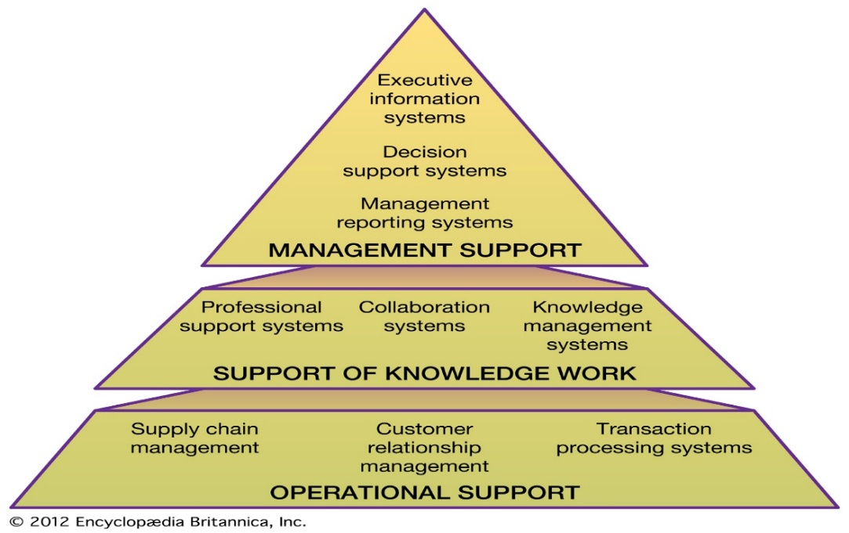

***1-4)information system life cycle:***

The development phase of the life cycle for an information system consists of a feasibility study, system analysis, seystm design, programming and testing, and installation. Following a period of operation and maintenance, typically 5 to 10 years, an evaluation is made of whether to terminate or upgrade the system.

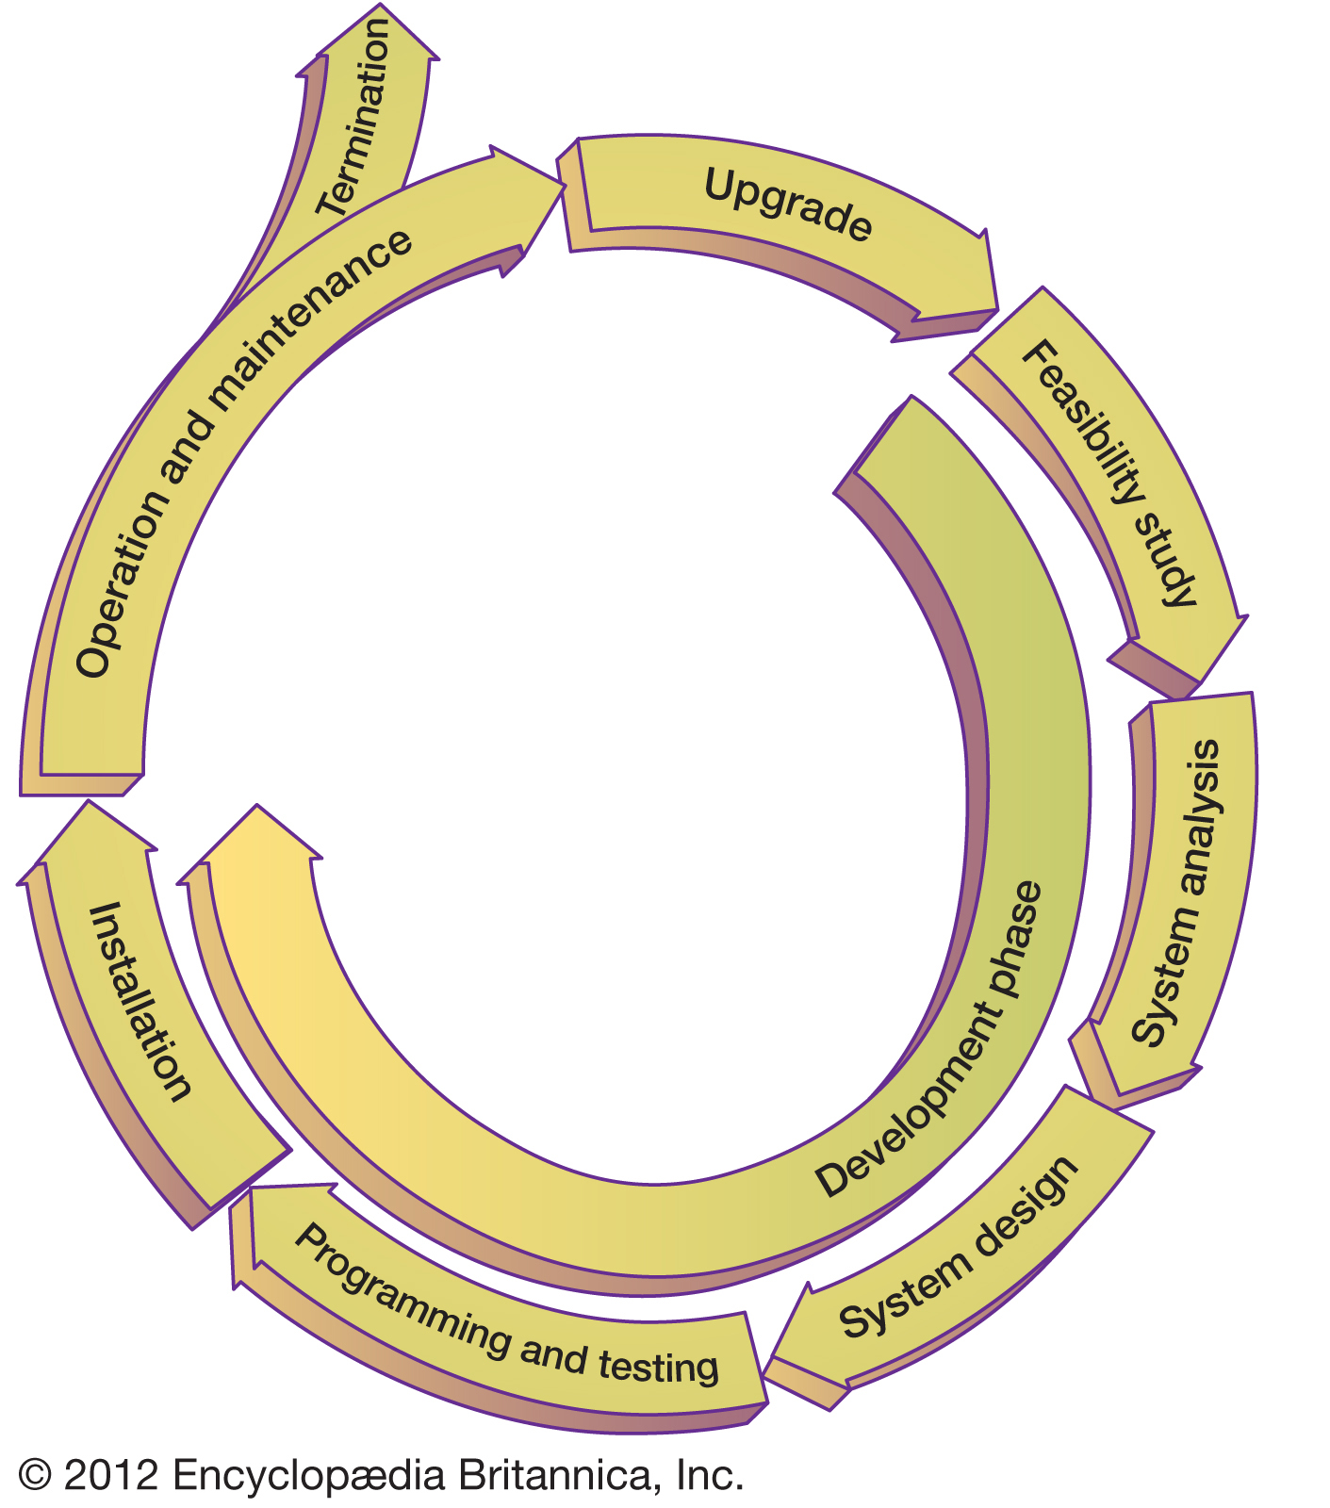

***2-Database:***

***2-1) Database Definition:***

-In simple words, data can be facts related to any object in consideration. For example, your name, age, height, weight, etc. are some data related to you. A picture, image, file, pdf, etc. can also be considered data.

-A database is a systematic collection of data. They support electronic storage and manipulation of data. Databases make data management easy.

Let us discuss a database example: An online telephone directory uses a database to store data of people, phone numbers, and other contact details. Your electricity service provider uses a database to manage billing, client-related issues, handle fault data, etc.

Let us also consider Facebook. It needs to store, manipulate, and present data related to members, their friends, member activities, messages, advertisements, and a lot more. We can provide a countless number of examples for the usage of databases.

***2-2) Types of Databases:***

* Distributed databases:
* Relational databases:
* Object-oriented databases:
* Centralized database:
* Open-source databases:
* Cloud databases:
* Data warehouses:
* NoSQL databases:
* Graph databases:
* OLTP databases:
* Personal database:
* Multimodal database:
* Document/JSON database:
* Hierarchical:
* Network DBMS:

***2-3) Database Components:***

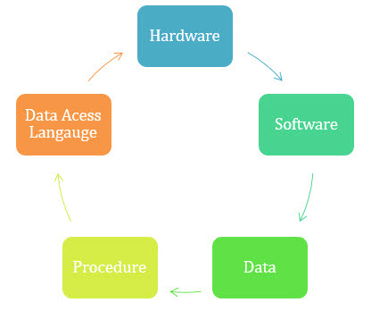

***2-4) Star Schema Model:***

Star schema is one of the simplest database models and is commonly used as a model for relational data warehouses and multidimensional databases. It consists entirely of fact tables and dimension tables. Fact tables are an event or entity such as a sale and a dimension table consists of details about that event such as date, place, speed of delivery, etc.

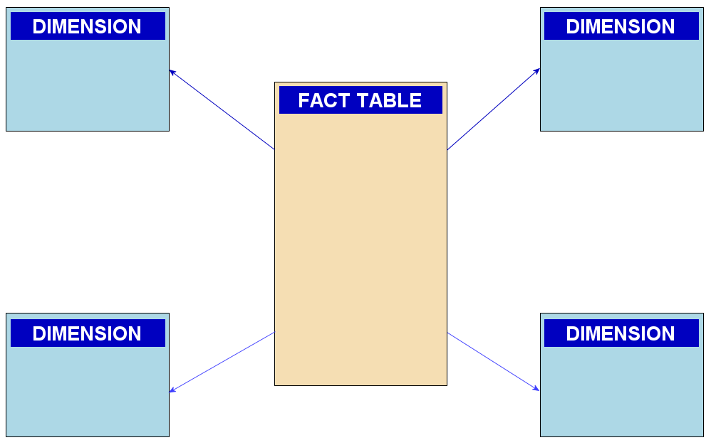

*(Star schema database)*

***Types of Relationships:***

There are three basic types of relationships among entities. These three types include:

* ***one-to-one*:**

Such a relationship exists when each record of one table is related to only one record of the other table.

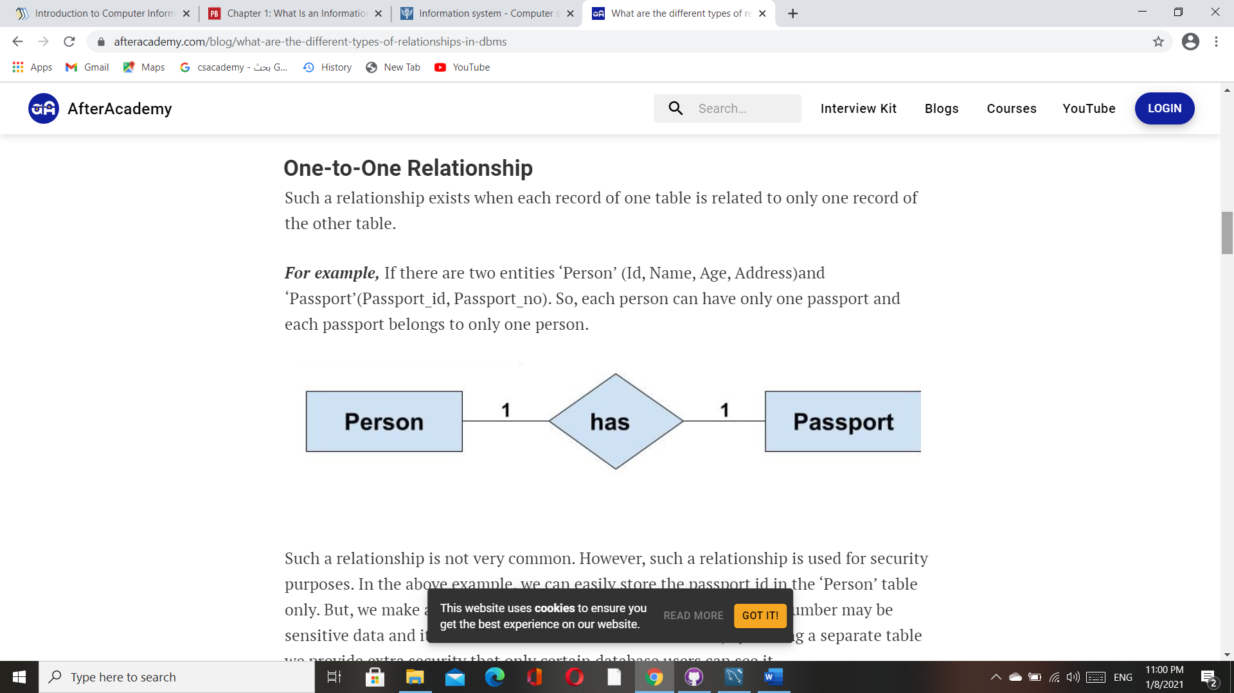

* ***One-to-Many or Many-to-One Relationship:***

Such a relationship exists when each record of one table can be related to one or more than one record of the other table. This relationship is the most common relationship found. A one-to-many relationship can also be said as a many-to-one relationship depending upon the way we view it.

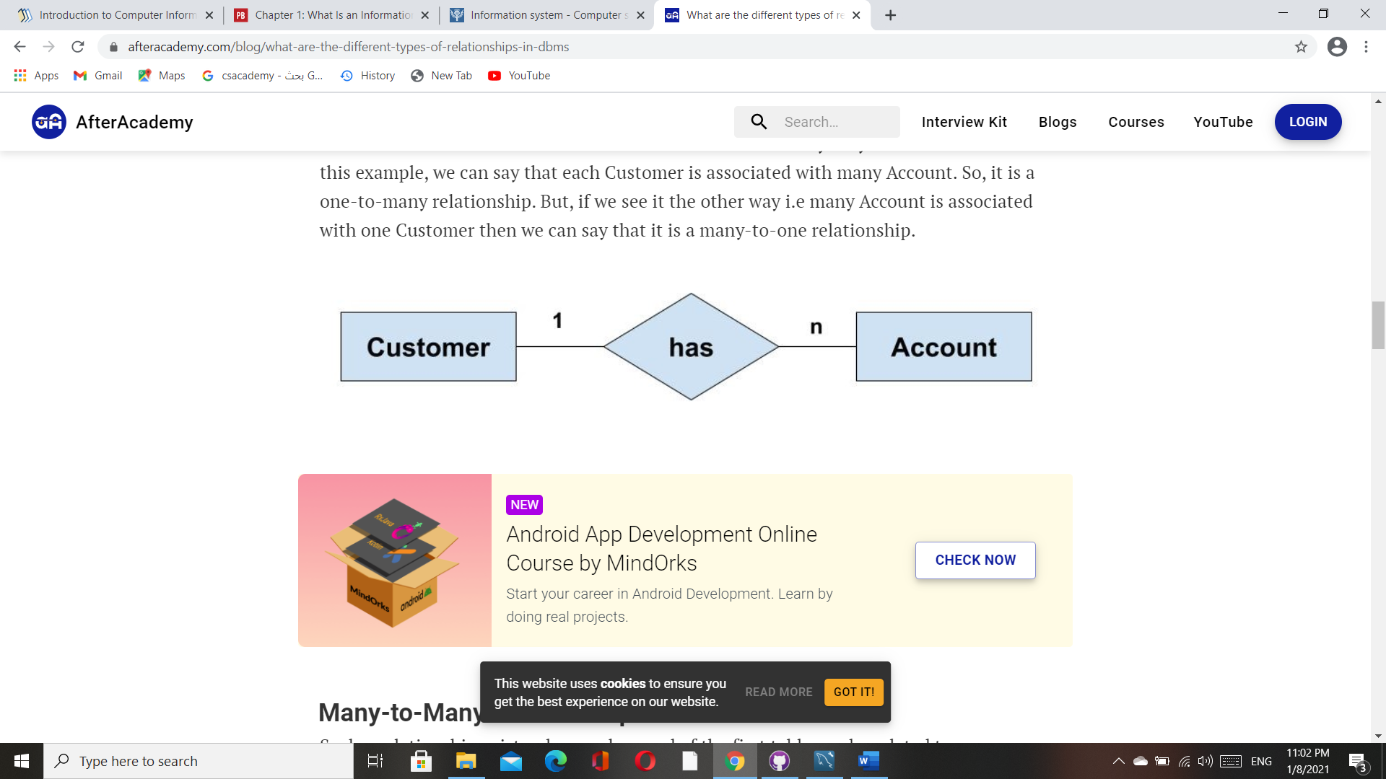

* ***many-to-many:***

Such a relationship exists when each record of the first table can be related to one or more than one record of the second table and a single record of the second table can be related to one or more than one record of the first table. A many-to-many relationship can be seen as a two one-to-many relationship which is linked by a 'linking table' or 'associate table'. The linking table links two tables by having fields which are the primary key of the other two tables.

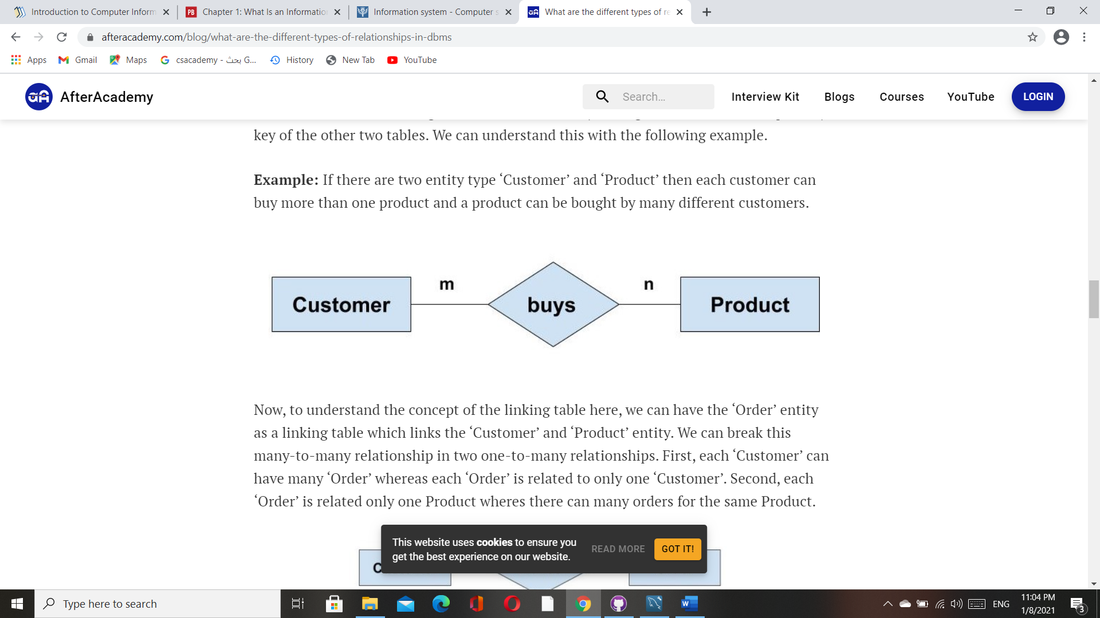

***Database Design (ERD):***

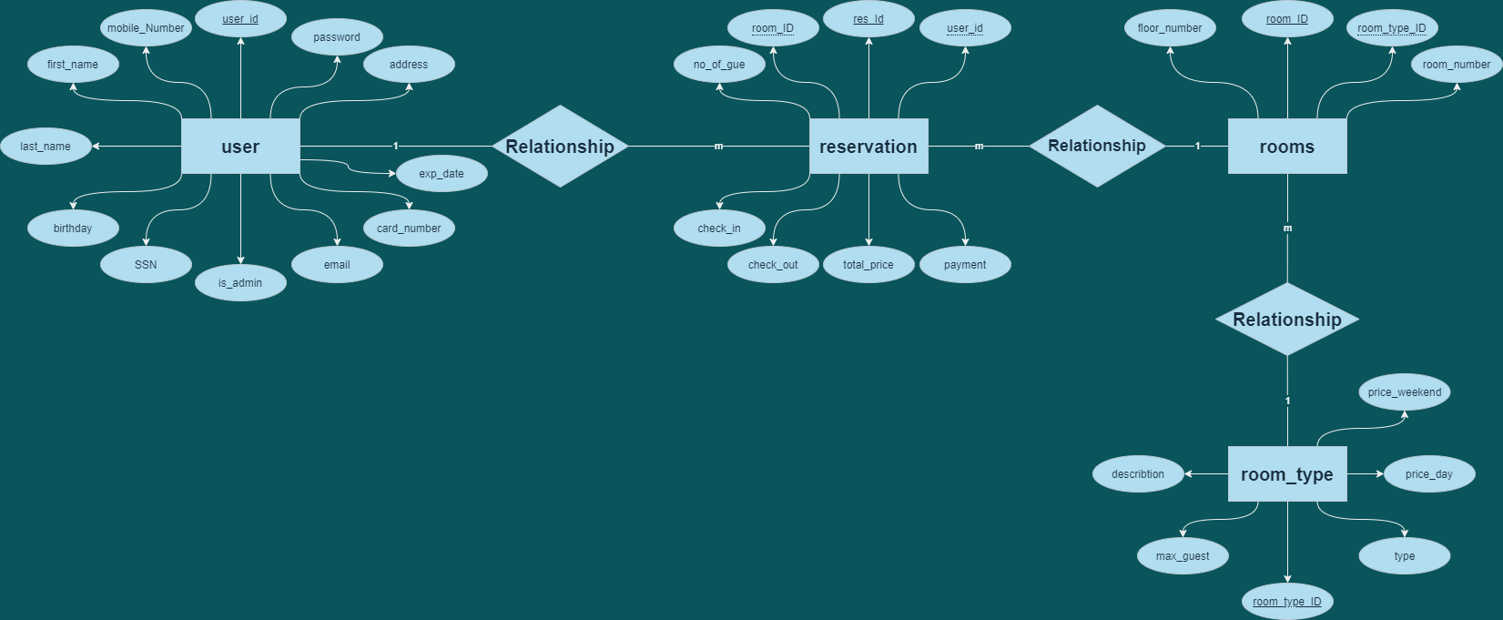

***Database Design (schema):***

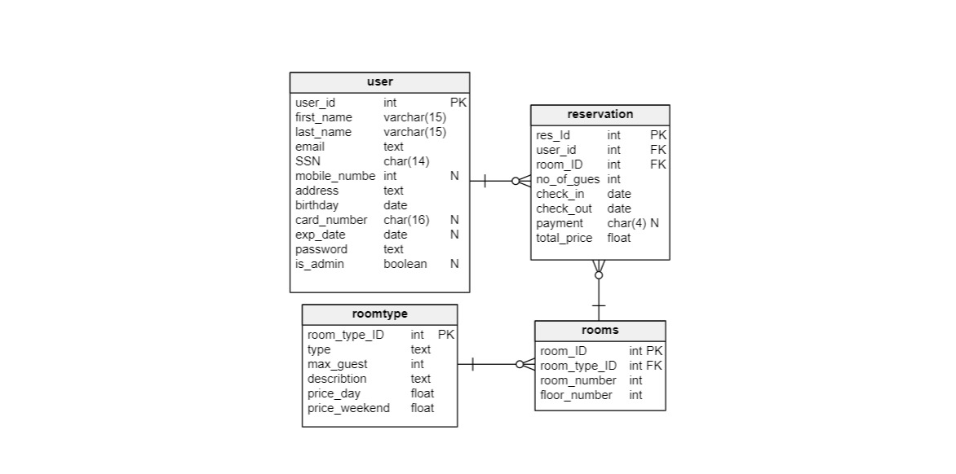

***Database Design (sql code):***

create database online_hotel_reservation;

use online_hotel_reservation;

create table user (

user_id int auto_increment,

first_name varchar(15) not null,

last_name varchar(15) not null,

email text not null,

SSN char(14) not null,

mobile_number int null,

address text not null,

birthday date not null,

card_number char(16) null,

exp_date date null,

password text not null,

is_admin boolean default false,

primary key (user_id)

);

create table roomtype(

room_type_ID int not null,

type text not null,

max_guest int not null,

describtion text not null,

price_day float not null,

price_weekend float not null,

img_src text not null,

primary key (room_type_ID)

);

create table rooms (

room_ID int not null,

room_type_ID int not null,

room_number int not null,

floor_number int not null,

primary key (room_ID),

foreign key (room_type_ID) references roomtype (room_type_ID)

);

create table reservation (

res_Id int auto_increment,

user_id int not null,

room_ID int not null,

no_of_guests int not null,

check_in date not null,

check_out date not null,

payment char(4) null,

total_price float not null,

primary key (res_Id),

foreign key (user_id) references user (user_id),

foreign key (room_ID) references rooms (room_ID)

);

insert into user(

first_name,

last_name,

email,

SSN,

mobile_number,

address,

birthday,

password,

is_admin

)

values(

'kholoud',

'elbaroudy',

'admin5122@admin.com',

'12345678910114',

01065648683,

'el_mokattam',

'1999-9-6',

'Kh4190183',

true

);

insert into roomtype(

room_type_ID,

type,

max_guest,

describtion,

price_day,

price_weekend,

img_src

)

values(

01,

'Single Room',

2,

'one bed',

300.00,

450.00,

"https://www.almrsal.com/wp-content/uploads/2014/12/White-Comfortable-Sofa-In-A-Modern-Stylish-Bedroom-With-Wall-Decor.jpg"

);

insert into roomtype(

room_type_ID,

type,

max_guest,

describtion,

price_day,

price_weekend,

img_src

)

values(

02,

'Double Room',

4,

'two beds',

600.00,

900.00,

"https://www.almrsal.com/wp-content/uploads/2013/12/twin-beds-boxwood-interiors.jpg"

);

insert into roomtype(

room_type_ID,

type,

max_guest,

describtion,

price_day,

price_weekend,

img_src

)

values(

03,

'Family Room',

6,

'three beds',

900.00,

1350.00,

"https://cf.bstatic.com/xdata/images/hotel/max1024x768/89274943.webp?k=d7be735d2112c1eecac7ce0b2a0998eb8cf514763a9f9428d8d1d29d051734e0&o="

);

insert into rooms(

room_ID,

room_type_ID,

room_number,

floor_number

)

values(100, 01, 1, 1);

insert into rooms(room_ID, room_type_ID, room_number, floor_number)

values(101, 01, 2, 1);

insert into rooms(room_ID, room_type_ID, room_number, floor_number)

values(102, 01, 3, 1);

insert into rooms(

room_ID,

room_type_ID,

room_number,

floor_number

)

values(103, 01, 4, 1);

insert into rooms(

room_ID,

room_type_ID,

room_number,

floor_number

)

values(104, 01, 5, 1);

insert into rooms(room_ID, room_type_ID, room_number, floor_number)

values(105, 01, 6, 1);

insert into rooms(room_ID, room_type_ID, room_number, floor_number)

values(106, 01, 7, 1);

insert into rooms(room_ID, room_type_ID, room_number, floor_number)

values(107, 01, 8, 1);

insert into rooms(room_ID, room_type_ID, room_number, floor_number)

values(108, 01, 9, 1);

insert into rooms(room_ID, room_type_ID, room_number, floor_number)

values(109, 01, 10, 1);

insert into rooms(room_ID, room_type_ID, room_number, floor_number)

values(110, 01, 11, 1);

insert into rooms(room_ID, room_type_ID, room_number, floor_number)

values(111, 01, 12, 1);

insert into rooms(room_ID, room_type_ID, room_number, floor_number)

values(112, 01, 13, 1);

insert into rooms(room_ID, room_type_ID, room_number, floor_number)

values(113, 01, 14, 1);

insert into rooms(room_ID, room_type_ID, room_number, floor_number)

values(114, 01, 15, 1);

insert into rooms(room_ID, room_type_ID, room_number, floor_number)

values(115, 01, 16, 1);

insert into rooms(room_ID, room_type_ID, room_number, floor_number)

values(116, 01, 17, 1);

insert into rooms(room_ID, room_type_ID, room_number, floor_number)

values(117, 01, 18, 1);

insert into rooms(room_ID, room_type_ID, room_number, floor_number)

values(118, 01, 19, 1);

insert into rooms(room_ID, room_type_ID, room_number, floor_number)

values(119, 01, 20, 1);

insert into rooms(room_ID, room_type_ID, room_number, floor_number)

values(120, 02, 21, 2);

insert into rooms(room_ID, room_type_ID, room_number, floor_number)

values(121, 02, 22, 2);

insert into rooms(room_ID, room_type_ID, room_number, floor_number)

values(122, 02, 23, 2);

insert into rooms(room_ID, room_type_ID, room_number, floor_number)

values(123, 02, 24, 2);

insert into rooms(room_ID, room_type_ID, room_number, floor_number)

values(124, 02, 25, 2);

insert into rooms(room_ID, room_type_ID, room_number, floor_number)

values(125, 02, 26, 2);

insert into rooms(room_ID, room_type_ID, room_number, floor_number)

values(126, 02, 27, 2);

insert into rooms(room_ID, room_type_ID, room_number, floor_number)

values(127, 02, 28, 2);

insert into rooms(room_ID, room_type_ID, room_number, floor_number)

values(128, 02, 29, 2);

insert into rooms(room_ID, room_type_ID, room_number, floor_number)

values(129, 02, 30, 2);

insert into rooms(room_ID, room_type_ID, room_number, floor_number)

values(130, 02, 31, 2);

insert into rooms(room_ID, room_type_ID, room_number, floor_number)

values(131, 02, 32, 2);

insert into rooms(room_ID, room_type_ID, room_number, floor_number)

values(132, 02, 33, 2);

insert into rooms(room_ID, room_type_ID, room_number, floor_number)

values(133, 02, 34, 2);

insert into rooms(room_ID, room_type_ID, room_number, floor_number)

values(134, 02, 35, 2);

insert into rooms(room_ID, room_type_ID, room_number, floor_number)

values(135, 02, 36, 2);

insert into rooms(room_ID, room_type_ID, room_number, floor_number)

values(136, 02, 37, 2);

insert into rooms(room_ID, room_type_ID, room_number, floor_number)

values(137, 02, 38, 2);

insert into rooms(room_ID, room_type_ID, room_number, floor_number)

values(138, 02, 39, 2);

insert into rooms(room_ID, room_type_ID, room_number, floor_number)

values(139, 02, 40, 2);

insert into rooms(room_ID, room_type_ID, room_number, floor_number)

values(140, 03, 41, 3);

insert into rooms(room_ID, room_type_ID, room_number, floor_number)

values(141, 03, 42, 3);

insert into rooms(room_ID, room_type_ID, room_number, floor_number)

values(142, 03, 43, 3);

insert into rooms(room_ID, room_type_ID, room_number, floor_number)

values(143, 03, 44, 3);

insert into rooms(room_ID, room_type_ID, room_number, floor_number)

values(144, 03, 45, 3);

insert into rooms(room_ID, room_type_ID, room_number, floor_number)

values(145, 03, 46, 3);

insert into rooms(room_ID, room_type_ID, room_number, floor_number)

values(146, 03, 47, 3);

insert into rooms(room_ID, room_type_ID, room_number, floor_number)

values(147, 03, 48, 3);

insert into rooms(room_ID, room_type_ID, room_number, floor_number)

values(148, 03, 49, 3);

insert into rooms(room_ID, room_type_ID, room_number, floor_number)

values(149, 03, 50, 3);

insert into rooms(room_ID, room_type_ID, room_number, floor_number)

values(150, 03, 51, 3);

insert into rooms(room_ID, room_type_ID, room_number, floor_number)

values(151, 03, 52, 3);

insert into rooms(room_ID, room_type_ID, room_number, floor_number)

values(152, 03, 53, 3);

insert into rooms(room_ID, room_type_ID, room_number, floor_number)

values(153, 03, 54, 3);

insert into rooms(room_ID, room_type_ID, room_number, floor_number)

values(154, 03, 55, 3);

insert into rooms(room_ID, room_type_ID, room_number, floor_number)

values(155, 03, 56, 3);

insert into rooms(room_ID, room_type_ID, room_number, floor_number)

values(156, 03, 57, 3);

insert into rooms(room_ID, room_type_ID, room_number, floor_number)

values(157, 03, 58, 3);

insert into rooms(room_ID, room_type_ID, room_number, floor_number)

values(158, 03, 59, 3);

insert into rooms(room_ID, room_type_ID, room_number, floor_number)

values(159, 03, 60, 3);

**home Page Design:**

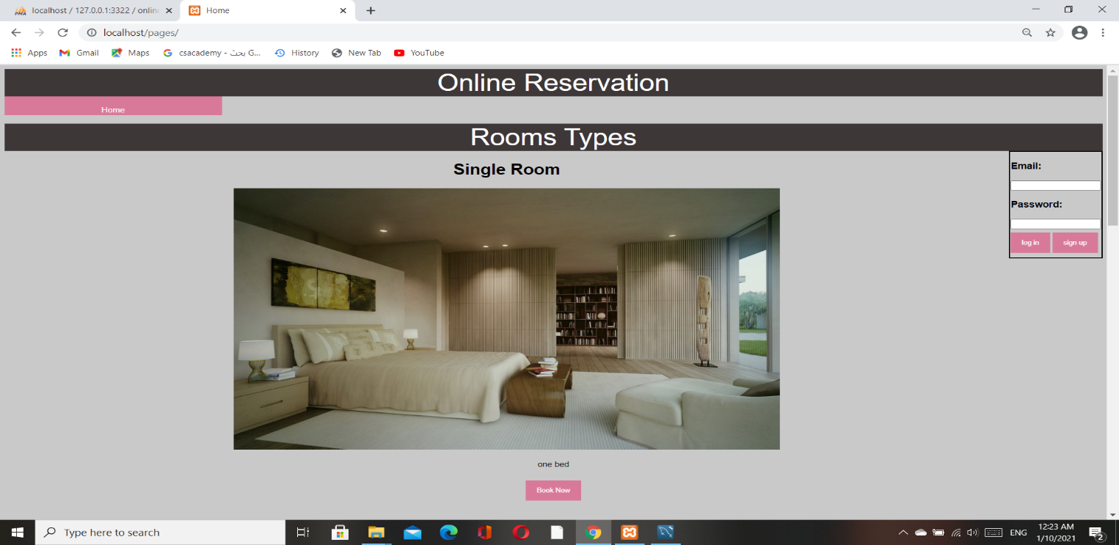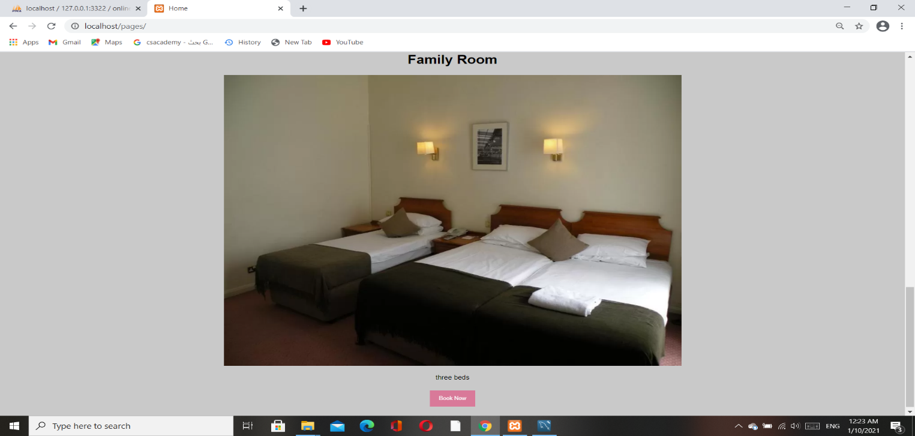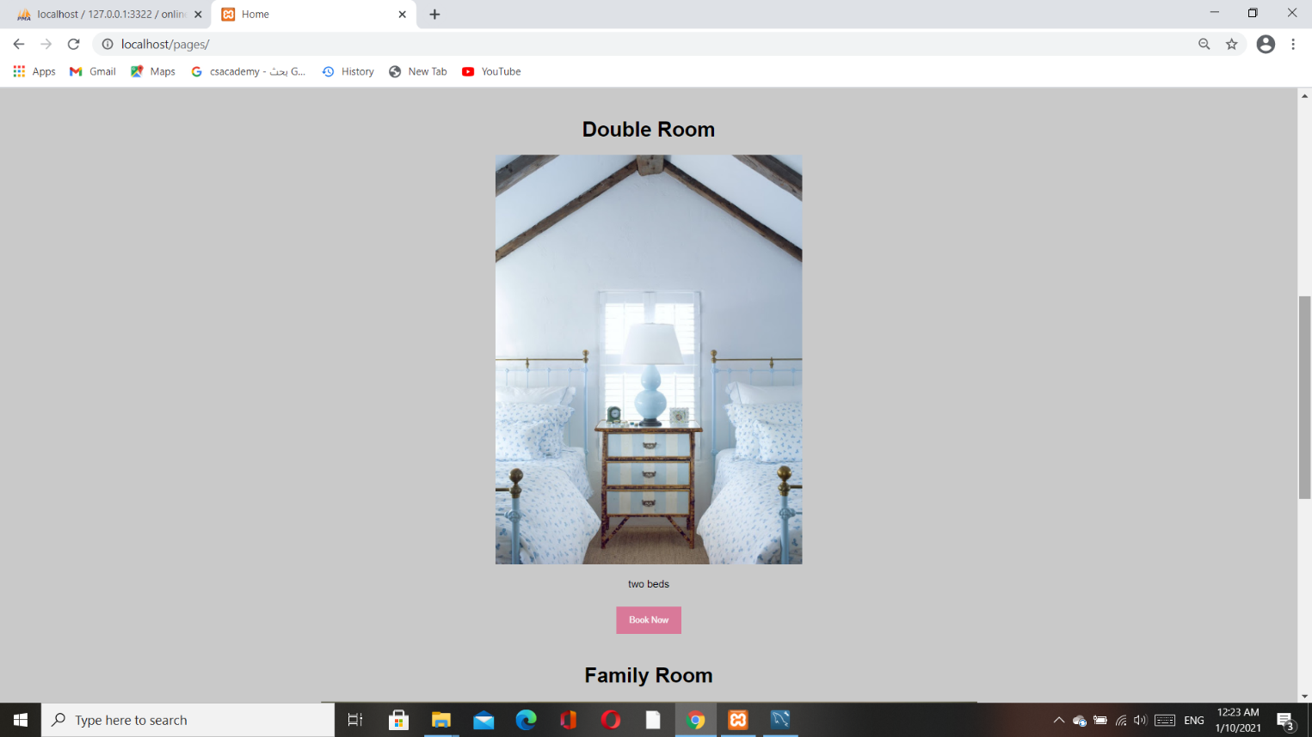

**Home page after log in:**

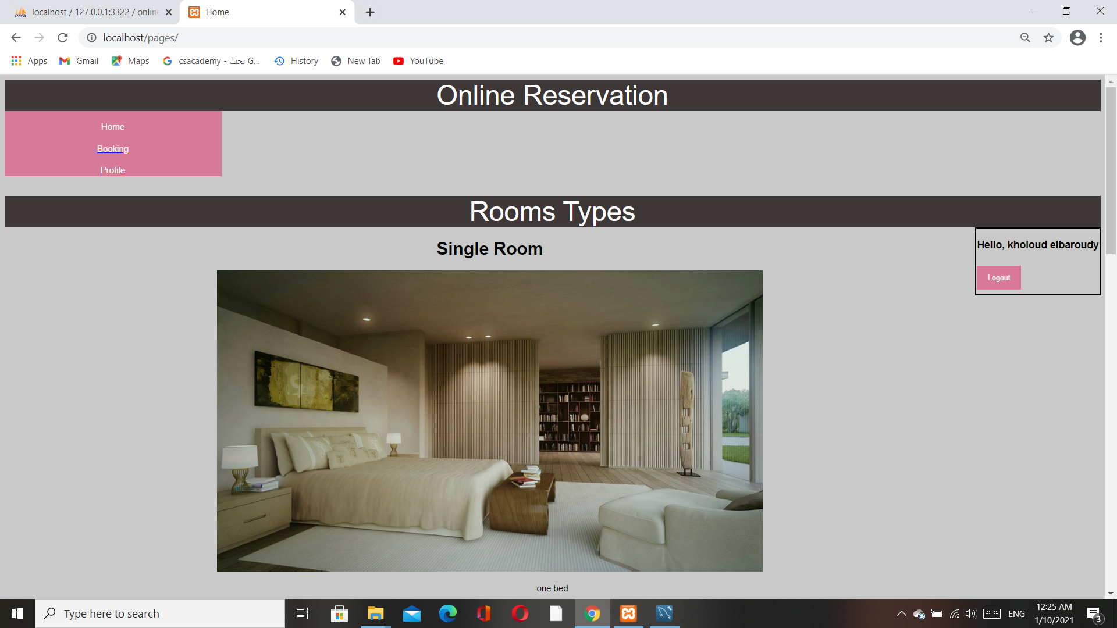

**Form page design:**

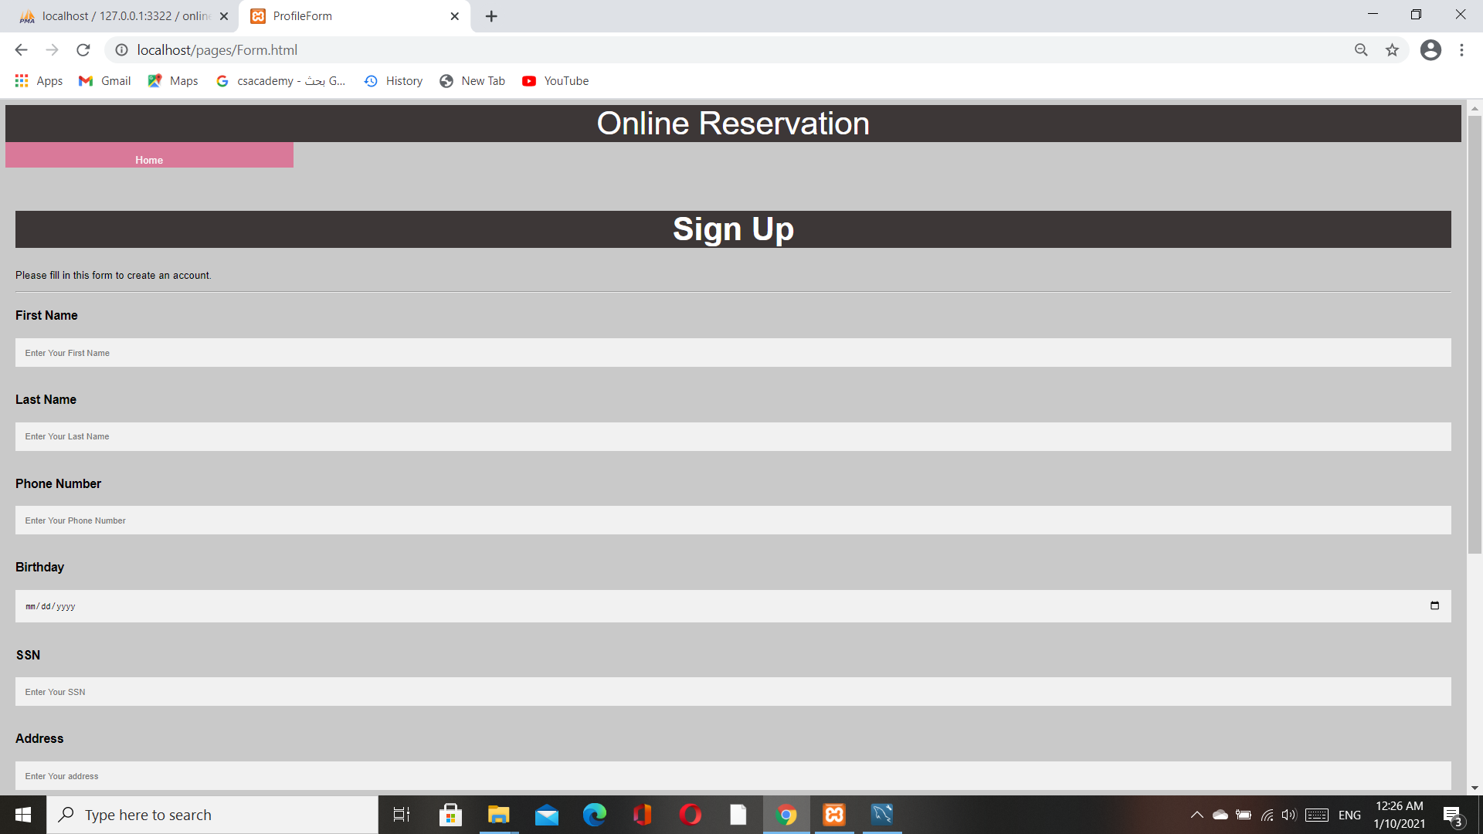

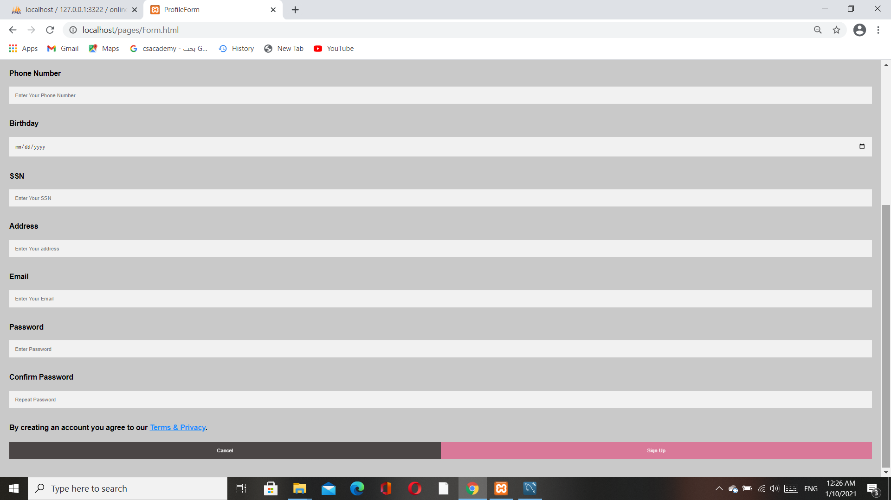

**Booking form design:**

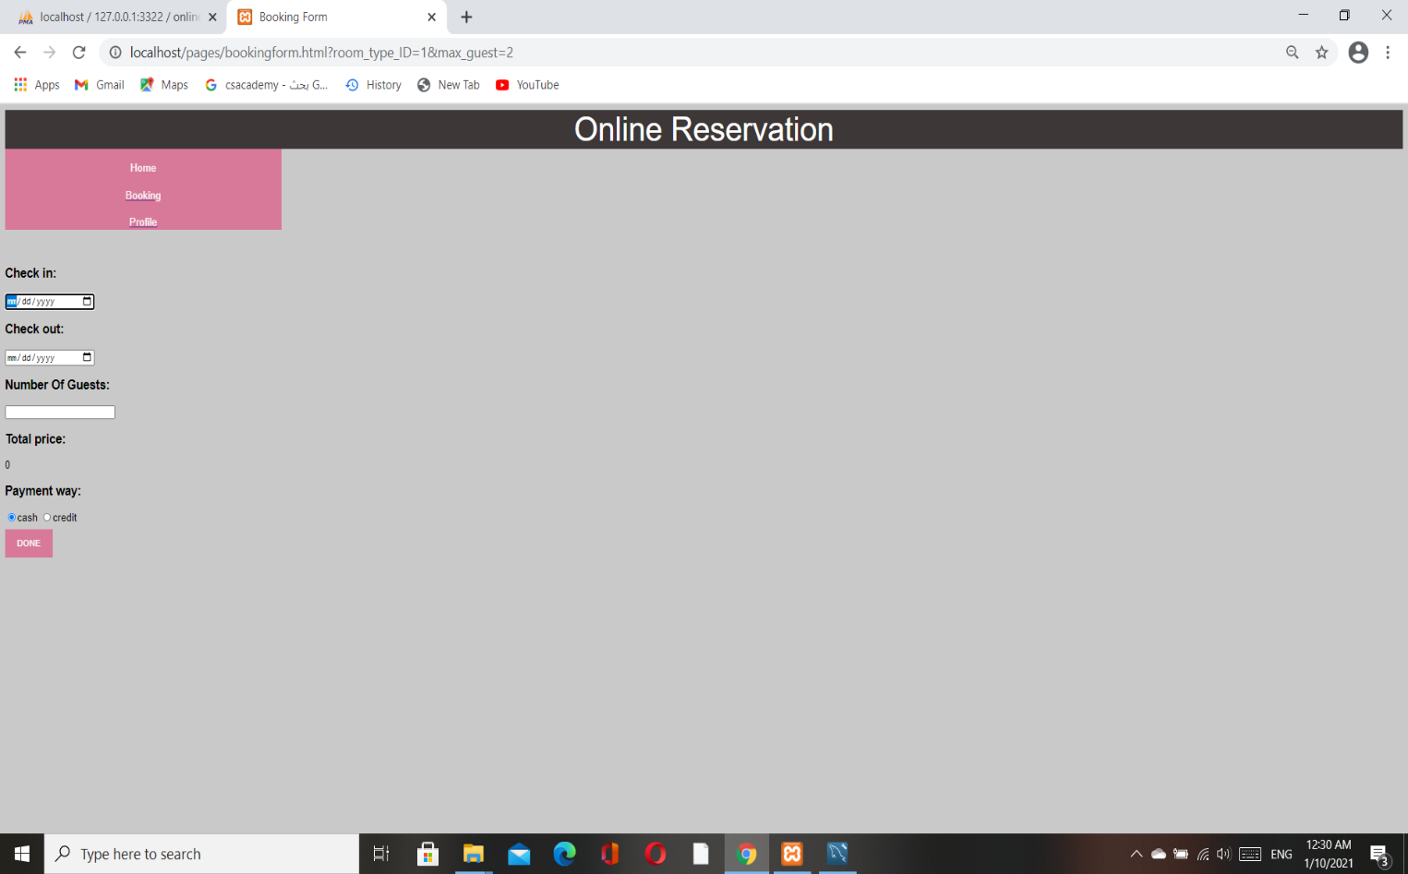

**When press on credit:**

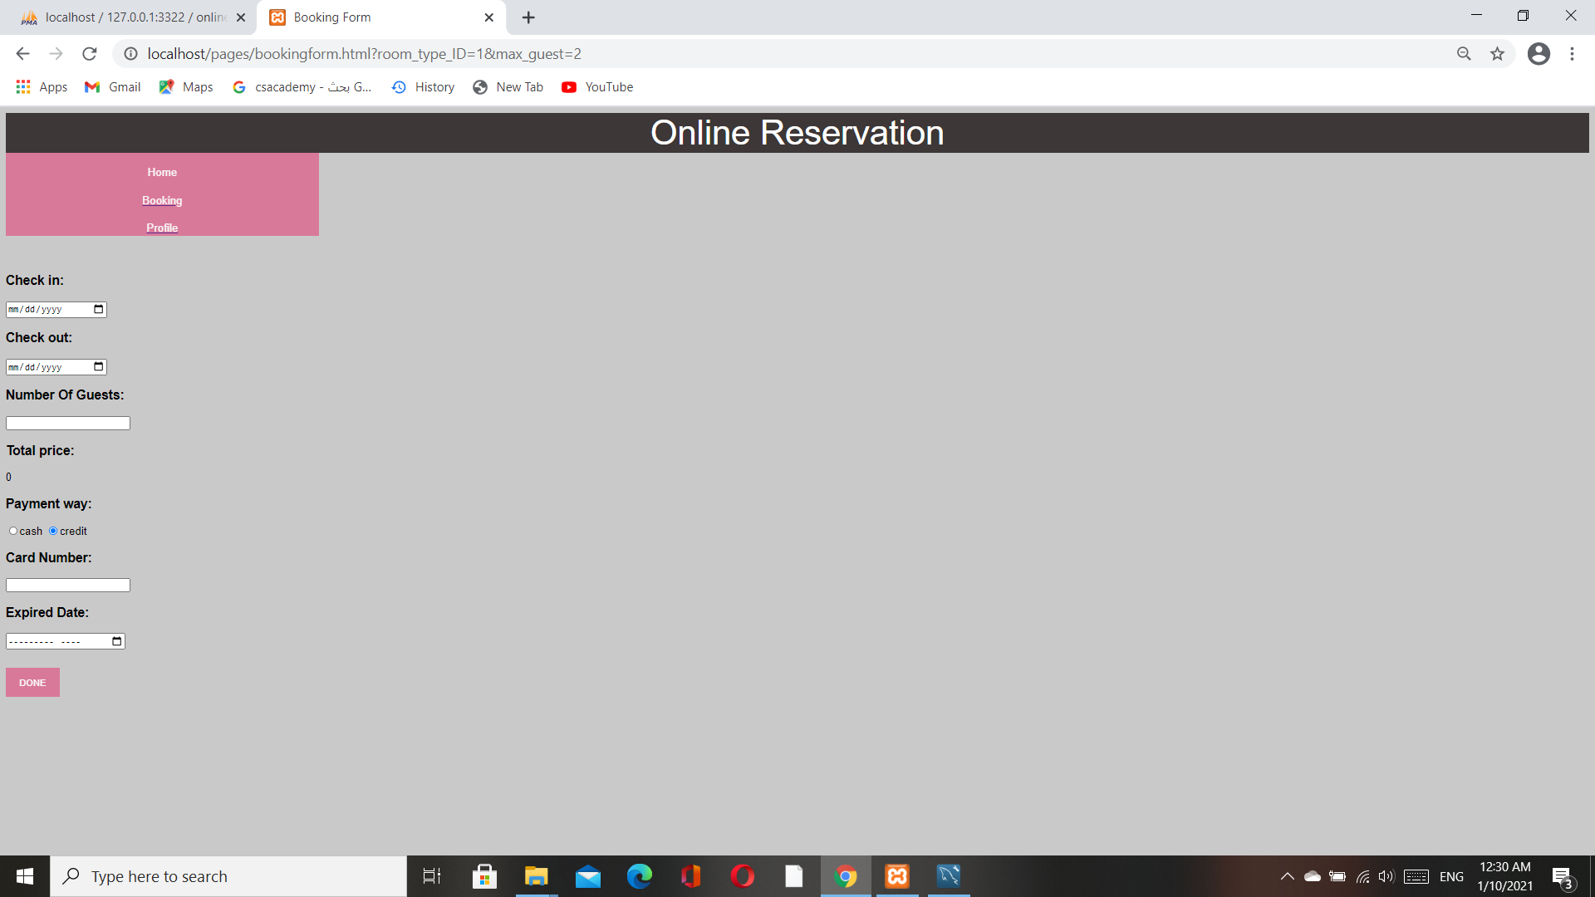

**Summary:**

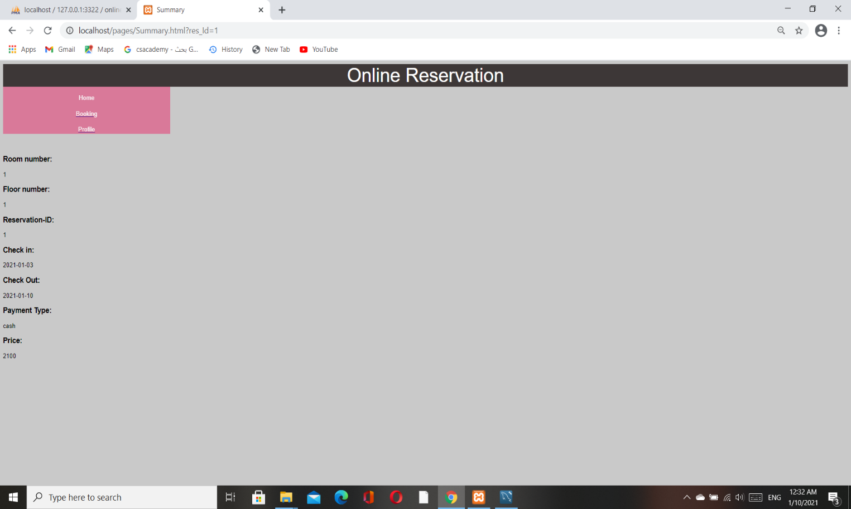

**Booking:**

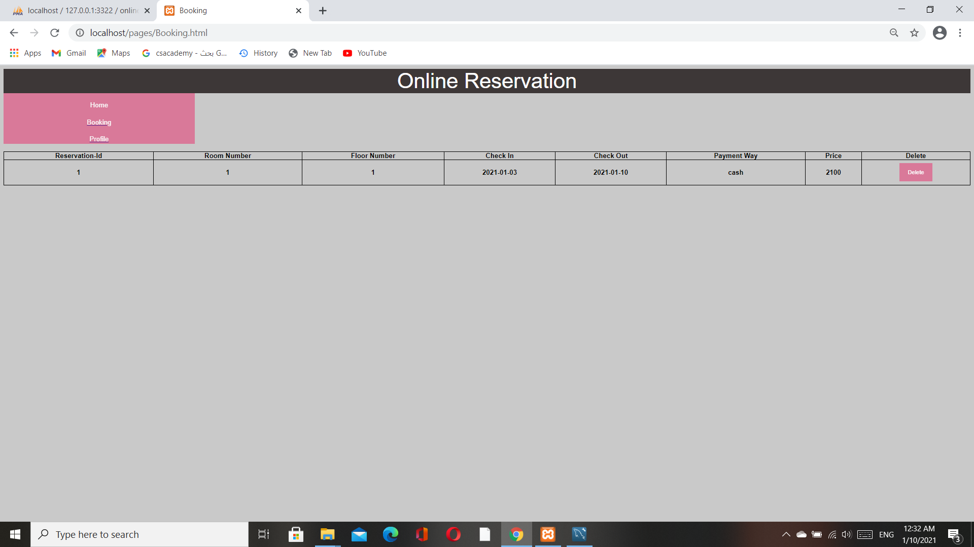

**Profile page:**

